9 A. Create a web application to demonstrate use of GridView button column and GridView events long with paging and sorting.
webform2.aspx :
<%@ Page Language="C#" AutoEventWireup="true" CodeBehind="WebForm2.aspx.cs" Inherits="WebApplication21.WebForm2" %>

<!DOCTYPE html>

<html xmlns="http://www.w3.org/1999/xhtml">
<head runat="server">
<title></title>
</head>
<body>
<form id="form1" runat="server">
<div>
<asp:GridView ID="GridView1" runat="server"></asp:GridView>
<asp:SqlDataSource ID="SqlDataSource1" runat="server"></asp:SqlDataSource>
</div>
</form>
</body>
</html>
setteing :
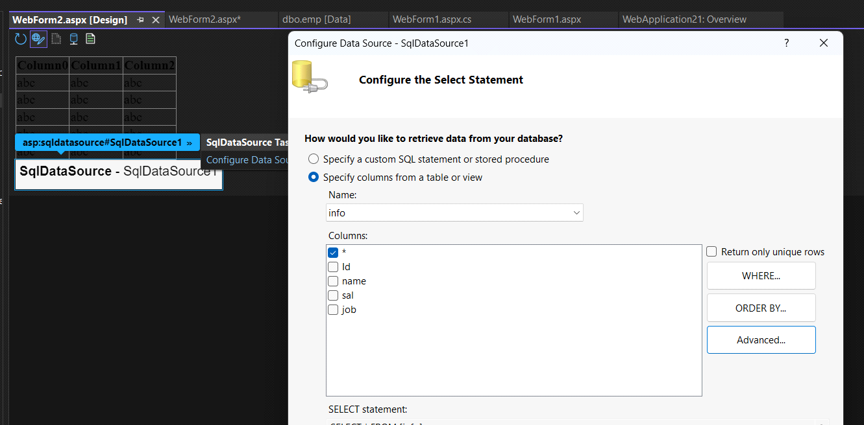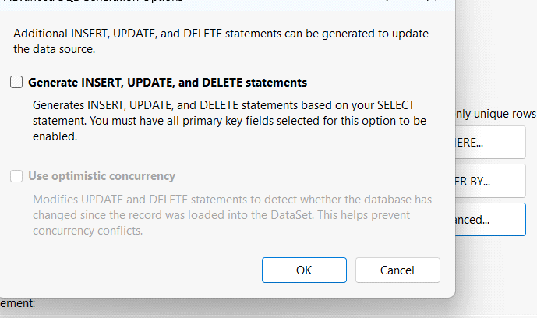
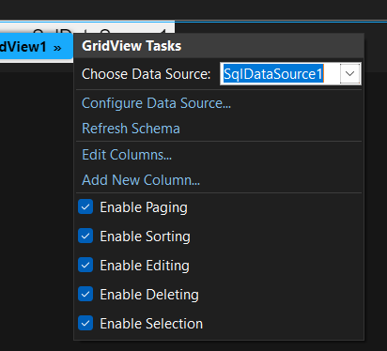
OUTPUT:
